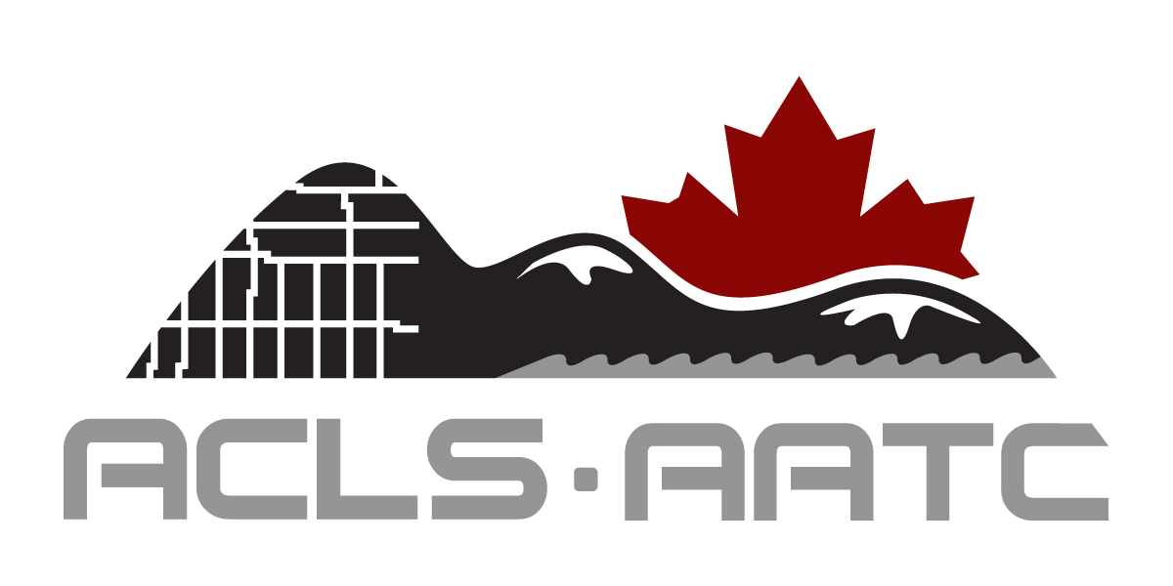
Application Form

Permit

APPLICATION FOR PERMIT AND AGREEMENT BETWEEN THE LICENSED CLS(S) AND THE ENTITY

Name of Entity:
Address:
Municipality: Prov./ Terr.: Postal Code:
Tel.: Ext.: Fax:
______________________________________________________________________________________
List of Licensed Canada Surveyor(s) responsible for surveying services (Section 32.(b), CLS Reg.)
Fill the appropriate box with the letter corresponding to the type of relationship between the Licensed
Surveyor and the Permit Holder: E for Employee, A for Associate or D for Director (Administrator).
AGREEMENT: The above-mentioned entity acknowledges that the following Licence Holder (s) will be the responsible Canada Land Surveyor(s) for surveys carried out by the said entity. All parties agree to notify the ACLS of any changes to this agreement. This agreement is effective immediately.
______________________________________________________________________________________
Name : Signature: _______________
Municipality : Prov./ Terr.: Relationship:

Name : Signature: _______________
Municipality : Prov./ Terr.: Relationship:

To list more Surveyors please attach a separate sheet.
If your intention is to include an ACLS Licence Holder who is already named on another permit, you must first contact the Registrar for details on ACLS guidelines. See second page for Documentation Required for the Permit Application.
_____________________________________________________________________________________

Applicant Information Application made on behalf of Entity by:

Approved by

………………………………………….… ………………………………………………..
Signature Date Registrar Date
_____________________________________________________________________________________
Please enclose the following:
☐ Annual Permit Fee of $445.00

Please indicate method of payment:
To pay through our secure gateway, go to the “forms” section and click the appropriate icon.
☐ Cheque enclosed ☐ MasterCard ☐ Visa

……………………………………………………….. ……………………………………………
Signature Date

Documentation Required for the Permit Application

Entities applying for a permit must provide these documents to ensure that surveying is one of the entity’s principal activities:

- In the case where the entity is a corporation, a copy of the official corporate documents that set out its business activities (the “objects” of the corporation).
- In the case where the entity is a partnership, a copy of the parts of the partnership agreement that sets its business activities.
- In the case where the entity is an unincorporated organization or association, a copy of the parts of the organizational documents that specify its business activities.

The submission should include those documents that clearly state that surveying is one of the functions of the entity.

To ensure that the entity (1) has at least one ACLS licence holder amongst its senior management staff; (2) the licence holder is involved in the decision making process as it relates to surveying activities on Canada Lands; (3) the licence holder has actual authority and means within the entity to control surveying activities on Canada Lands, one or more of the following documents must accompany the permit application:

- In the case of an incorporated or limited company, an official list of the members of the Board of Directors which includes at least one licensed ACLS member (for example it could be a copy of the most recent annual return to Corporations Canada if federal)
- An organization chart
- Job description of the licensed CLS(s)
- Any other document illustrating the licensed CLS’s responsibilities.

If the CLS(s) is (are) member(s) of the Board of Directors, the CLS(s) is (are) deemed to have sufficient authority for the purpose of section 33(b). If some of the requested documents do not exist, then an affidavit or statutory declaration signed by the Chief Executive Officer and the licensed CLS(s) declaring that the CLS(s) has(have) full authority and means to control surveying activities on Canada Lands is deemed sufficient.

The entity must also provide proof of professional liability insurance coverage with same requirements as stated in section 29 of the Canada Lands Surveyors Regulations.

