SPONSOR AND EXHIBITOR OPPORTUNITIES

It is with great pleasure that we invite you to take part in the sixteenth National Surveyors’ Conference from May 11th to 13th in Kanata, Ontario, which will be held in conjunction with Professional Surveyors Canada.
The upcoming conference will be held at the Brookstreet Hotel. Spaces for exhibits have been reserved in the Grand Scheme Foyer of the hotel for May 11th and 12th.
These conferences are always well attended, as they are the only national professional surveyors’ conference. For the 2022 conference, we are expecting 200 surveyors.
Jean-Claude Tétreault, CLS, a.-g. (ret.), MBA. Association of Canada Lands Surveyors Executive Director

Michelle Zuk, MBA, Executive Director, Professional Surveyors Canada
James Dorland, BSc.E, OLS, OLIP, P. Surv D.S. Dorland Limited, Project Coordinator

Cindy Kliaman, CLS, OLS, OLIP, AGO, PITO Manager, Ontario Regional Office / Surveyor General Branch, Natural Resources Canada

Geneviève Marquis CLS, a.-g. Senior Surveyor, Surveyor General Branch
Natural Resources Canada

Jenny Cooper, Association of Canada Lands Surveyors Communications Officer

Organizing committee

WHY YOUR COMPANY SHOULD SUPPORT THIS EVENT

These conferences are always well attended, as they are the only national professional surveyors’ conference.
For the 2022 conference, we are expecting a mix of 200 surveyors online and in person at the event.

CONFERENCE LOCATION

Brookstreet Hotel, 525 Legget Drive, Ottawa, Ontario K2K 2W2
Book your room HERE!
Reservations can be made via the link, by phone 613.271.3586 or by email reservations@brookstreet.com and quote the ACLS group to get the preferred rate.

PROMOTIONAL STRATEGY

A diverse program that ensures the participation of a large audience.
• Guest speakers
• Continuing professional development seminar sessions
• Poster submissions
• Virtual Platform (hybrid conference)

SPONSOR AND EXHIBIT OPPORTUNITIES

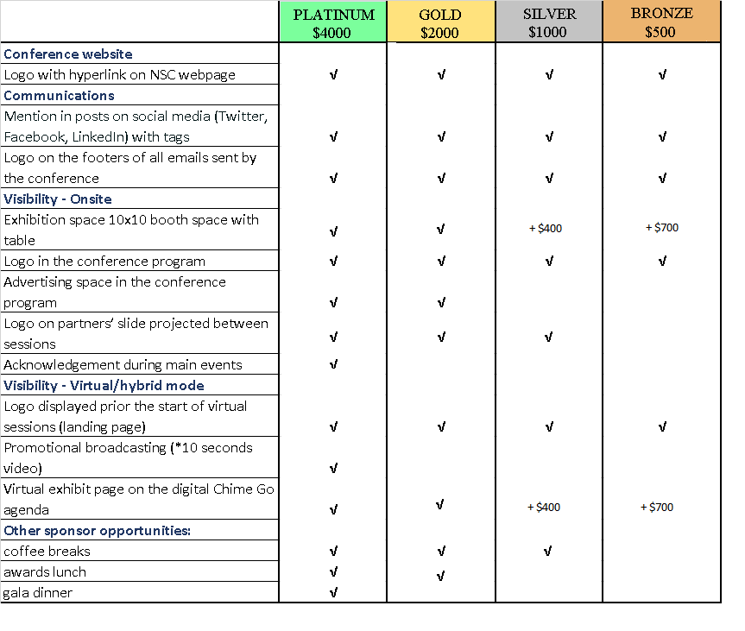

SPONSOR/EXHIBITOR APPLICATION AND CONTRACT

Sponsor coordinates: (Please print)

Contact name: _________________________________________ Company or Organization:

Address:

Municipality: ____________________________________ Prov./Terr.:_________________ Postal Code:

Tel.: _____________________________________ Ext. :________________

Email:______________________________________________ Web site:

Product/Service

Sponsor level: Platinum: Gold: Silver: Bronze:

Please attached a high-def image of your company logo in jpeg, png or gif. Attached

LinkedIn ___________________________ Facebook _________________________ Twitter _________________________

Instagram __________________________ Other _____________________________

Payment

This application must be accompanied by the total amount due. The Application will not be confirmed until payment is received.

Please indicate method of payment:

Cheque (payable to the Association of Canada Lands Surveyors)

Credit card (Visa or MasterCard only. Go to our secure on-line payment system at: https://www.acls-aatc.ca/product/pay- an-invoice/ . Instead of an invoice number, enter “exhibitor and company name” all in one word. Ex: Name of company is Acme Inc.. Enter “ExhibitorAcme’.

If this application is accepted, the Sponsor/Exhibitor agrees to be bound by the terms and conditions on the following page of this application and contract. The undersigned is fully authorized to commit the Sponsor/Exhibitor to all terms and conditions of this contract. Contract will be returned if unsigned or incomplete.

Signature: _______________________________ Name: ________________________Date: _________________

Terms and Conditions of Contract Between the Sponsor/Exhibitor
and the Association of Canada Lands Surveyors (ACLS)

- The ACLS reserves the right, at its sole discretion, to change the date or dates upon which the show is held or to cancel the show and shall not be liable in damages or otherwise by reason of any such change or cancellation, other than to refund in full any amounts paid by the Exhibitor/Sponsor to the ACLS.

- The Exhibitor/Sponsor shall not assign this contract or sublet the space or any part thereof or permit same to be used by any other person, without the prior written consent of the ACLS. Any attempt to do so is null and void and will result in immediate cancellation of this contract with no refund.

- The Exhibitor/Sponsor shall comply with all rules and regulations set by the ACLS for the show and agrees that ACLS’s decision to adopt and enforce any such rule or regulation shall be final and binding.

- The Exhibitor is responsible for compliance with all applicable laws, bylaws, ordinances, regulations, requirements, codes and standards, including those with respect to fire, safety, health and environmental matters and shall ensure that all equipment, materials and goods used by the Exhibitor so comply.

- The Exhibitor shall indemnify and hold harmless the ACLS from and against any loss, injury or damages whatsoever suffered by the ACLS as a result of the Exhibitor’s failure to comply with the terms and conditions of this contract or as a result of the Exhibitors’ participation in the show, including without limitation, any third-party claim against the ACLS with respect to loss, injury or damage sustained or suffered by any other exhibitor, the owner of the building, attendees of the tradeshow, and their respective directors, officers, agents and employees.

- In consideration of the Exhibitor/Sponsor participation in the show, the Exhibitor hereby releases the ACLS, its directors, officers, agents, and employees from any and all claims, losses, or damages whatsoever suffered or sustained by the Exhibitor/Sponsor in connection with the show, including, without limitation, any claims for loss or theft of property, personal injury, or loss of business or profits whether arising from any act of the ACLS or otherwise.

- This contract may be cancelled by either party provided written notice is received by the other before April 1th, 2022 in which case all monies paid by the Exhibitor will be refunded. If the Exhibitor/Sponsor cancels after such date, it will be responsible for the full contract price. Cancellations must be made in writing, on company letterhead.

- The ACLS reserves the right at any time to alter or remove exhibits or promotional material or any part thereof, including printed material, products, signs, lights or sound and to expel exhibitors or their personnel if, in the ACLS’s opinion, their conduct or presentation is objectionable to the ACLS or to other exhibit participants.

- Exhibitor’s display must comply with all requirements of the ACLS and of the owner of the building, including maximum height requirements.

- The Booth Exhibitors must provide at least one person, to a maximum of two persons per booth and /or launch, during showcase hours. The Exhibitor agrees to confine its presentation to the contracted space only.

- Goods must not be shipped to the show with any shipping charges to be paid on arrival and any such goods will not be accepted by the ACLS. The ACLS assumes no responsibility for loss or damage to the Exhibitor’s goods or property before, during or after the show.

- The Exhibitor/Sponsor is responsible for the placement and cost of insurance relating to its participation in the show. The Exhibitor/Sponsor agrees to furnish immediately to the ACLS upon request certificates of insurance pertaining to all policies of insurance carried by the Exhibitor/Sponsor together with satisfactory evidence from the insurers of the continuation of such policies. If the Exhibitor/Sponsor fails to comply with any of the foregoing, in addition to any other rights or remedies available to the ACLS at law or under this contract, the ACLS shall have the right to take possession of the display space for the purposes as it sees fit and the Exhibitor/Sponsor will be held liable for the full contract price for the said space.

- The Exhibitor/Sponsor agrees that no display may be dismantled, or goods removed during the scheduled time of the tradeshow. The Exhibitor agrees to remove the exhibit, equipment and appurtenances from the event building by the final move-out time. In the event of failure to do so, the Exhibitor agrees to pay for such additional costs as may be incurred by the ACLS.

- The Exhibitor/Sponsor will comply with the rules and regulations of any unionized contractors that may be selected by the ACLS to service the exhibitors. Any dispute between the Exhibitor/Sponsor and any such contractor or union representative will be referred to the ACLS for resolution, whose decision shall be final and binding on all parties.

The ACLS reserves the right to cancel this contract and to withhold possession of the space or to expel the Exhibitor/Sponsor there from if the Exhibitor/Sponsor fails to comply with any terms and conditions of this contract or the show rules and regulations, in which case the Exhibitor/Sponsor shall forfeit as liquidated damages and not as a penalty, all payments made pursuant to this contract, all without limiting the ACLS’s other rights and remedies at law under this contract as a result of such failure to comply.

Signature: __________________________ Name: ___________________________ Date: ______________________

