Real Time Kinematic - ACLS Best Practices

Because GNSS measurement and data reduction processes are complex, the following
guidelines focus primarily on assessing the reliability and accuracy of these surveys.
As GNSS technologies evolve and new methodologies become available, the
Land Surveyor responsible for the plan shall comply with these guidelines and their
intent. (*From ALSA manual of standard practice)

GNSS Positioning:

GNSS positioning can be affected for several reasons including:

- Atmospheric Conditions
- Multi-Path propagation
- Clock (Receiver and Satellite)
- Radio Interference
- Satellite geometry

Accuracies

Survey Accuracies:
For GNSS survey accuracies we must consider traditional surveying errors such as; rover pole (pogo) level, Tribrach centering, typing errors, as well as GNSS positioning errors.

GNSS Accuracies:
Typical GNSS equipment will have a Horizontal positioning accuracy of:
~1cm + 2ppm (with respect to the base station)

~1 ppm = 1mm/km
Part Per Million (PPM) means that for every kilometer the rover goes away from the base, another millimeter of given error is added to each measurement.

Recommended RTK Setup:
Below is the recommended typical RTK setup. Portions italicized indicate a better RTK set up to consider:

- Set up Base Station
  - Record static data on the base
  - Record the height in metres and feet
Adding an additional base station will give true redundancy for all observations.

- Place or observe a check shot
  - Should be placed at least 10m away from the base

- Survey Monuments (it is recommended to have an extended time between your initial shot and check shot to confirm Measurements and Accuracies are achieved)
  - 5 Epochs on initial observation (assuming bi-pod to reduce rover pole (pogo) movement).
  - 20 Epochs on initial observation, if not using a bi-pod.
If additional base was set-up observe the evidence from both bases.
  - Adjust rover pole (pogo) height by a minimum of 0.30m, rotate rover pole (pogo) orientation, and lose initialization and re-observe (store observation and identify on field notes)
    - The change in height is to:
      - Reduce blunder error in Height of Target.
      - Slightly reduce the Multi-Path environment.
    - Rotating the pogo helps to reduce rover pole (pogo) bubble level error.
    - Initialization loss to ensure new location is independently solved for.

- Observe and record check shot in step 2 again at the end of the day

- Process base station static data (Precise Point Positioning PPP)

Scenario

You have a job that has you placing pins 2.5km from your base station.

Assumptions:
Tribrach and rover pole (pogo) level is 2 and 3mm respectively

Survey Accuracies (assumed) = 5mm
GPS Accuracies = 10mm + 2mm/km * 2.5 km = 15mm (1.5cm)
This makes our point accuracy 0.02m (2cm), however as surveyors we require the relative accuracy between points which in this case is ~2.8cm.
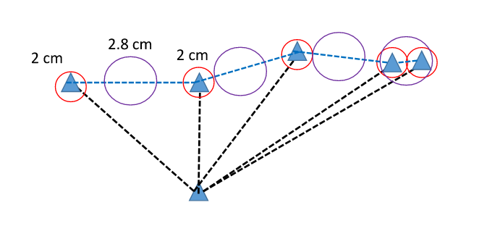

As you can see from the figure above, if you are placing 2 pins 200m apart or 10m apart the relative accuracies are similar therefore:

- The 200m distance will achieve the “Survey Accuracy” required in the National Standards for the Survey of Canada Lands.
- The 10m distance will NOT achieve the “Survey Accuracy” required in the National Standards for the Survey of Canada Lands.
  - To achieve the required accuracies a total station can be setup with a long backsight using GNSS, and turn the angle and distance to place the pin.

