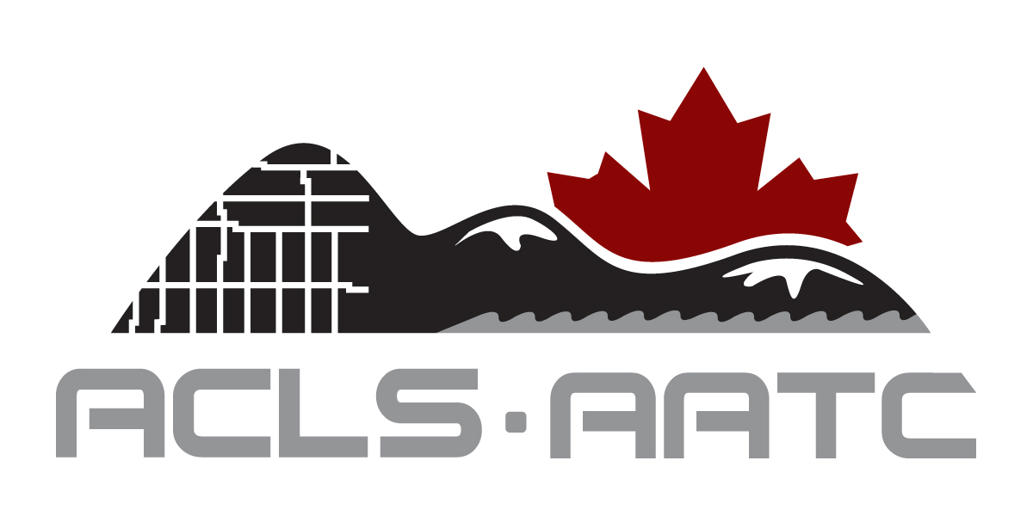

Application Form
ACLS Foundation Geomatics Scholarship Program

First Name:

Surname: Dr. Mr. Ms. Mrs.

Institution:
Institution’s e-mail:

Applicant’s Address:
Municipality: Prov./Terr.: Postal Code:
Tel.: Fax:
Email:

Where did you hear about the scholarship program?
My institution
Career Fair
Friend
Family
Other (Please specify)
_________________________________________________________________________

It is not mandatory to answer the following question unless you are applying for
the scholarship targeted toward aboriginal students.

Are you an aboriginal person? Yes No

It is mandatory to include all the required documents
_________________________________________________________________________

Important

Please keep copies of your application and all documentation, as they will
not be returned to you. Personal information will not be made available to
others outside the organization. The decision of the ACLS Foundation is
final.

Return this application to:

Association of Canada Lands Surveyors Foundation Inc.

